Ministry of Environment and Energy

Design and Build of Coastal Protection Structures at Hulhudhoo
(AGR) 438-ECAS/PRIV/2016/88

Monthly Progress Report – May

Report No
1

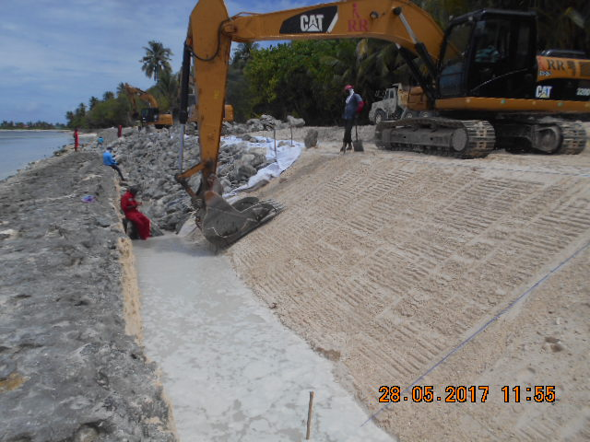
01st May 2017 – 31st May 2017
Report No 2

Presented by: Contractor, RR Maldives (Pvt) Ltd
Presented to: Project Engineer, Ministry of Environment and Energy
Date: 02nd June 2017
Contents

Report No
2

CONTENTS
- Project Details
- Project Background
2.1 Scope of Work
2.2 Site Layout Plan
- Site Organisation Chart
- Details of Bonds and Guarantees
- Details of Payments
- Program and Progress
6.1 Master Programme
6.2 Review of Project Progress against the programme
6.3 Layout View of Progress
- Resources – Manpower and Machinery & Vehicle
- Weather Record
- Issues and Public Complaints
- Progress Photographs

Document Control

Document Storage
Document Title: Design and Build of Coastal Protection Structures at S. Hulhudhoo
Author: Pabasara Kalansooriya
Last Updated: 02/06/2017
Last Saved by: Pabasara Kalansooriya

Version Control Log

Version | Author | Description of Changes | Date | Signature
V0-00 | Pabasara Kalansooriya,  Assistant Engineer (Head Office) | Initial Draft | 02/06/2017
V0-01 | Ranjith Senadhera,  Project Coordinator | Review and final Adjustments | 02/06/2017

Document Circulation

Organization | Designation | Name
Ministry of Environment and Energy | Minister of State | Mr. Abdulla Ziyad
Ministry of Environment and Energy | Assistant Director | Mr. Mohamed Ibrahim Jaleel
Ministry of Environment and Energy |  | Mr. Mohamed Zahir
Ministry of Environment and Energy |  | Mr. Ahamed Hassaan Zuhair
Ministry of Environment and Energy |  | Mr. Liusha Mohamed
Ministry of Environment and Energy |  | Mr. Aishath Huma

- Project Details

Project Name | Design and Build of Coastal Protection Structures at S. Hulhudhoo
Employer | Ministry of Environment and Energy, Green Building, Maafannu, Male’, 20392, Republic of Maldives.
Engineer | Ministry of Environment and Energy, Green Building, Maafannu, Male’, 20392, Republic of Maldives.
Contractor | RR Maldives Pvt Ltd
Contract Amount | MVR 24,446,024.96 with GST
Commencement | 27th November 2016
Construction period | 368 Days from the day of signing the contract
Scheduled date of completion | 30th November 2017
Defects Liability | 365 days
Retention | 5% of the certified work done  Limit of retention - 5% of the Accepted Contract Price

2.0 Project Background

2.1 Scope of Work
The government of Maldives wishes to build rock boulder revetments along the eroding shoreline of S. Hulhudhoo that are subjected to severe erosion.

The scope of works of the project is:
- Design and construction of rock boulder revetment to an extent of 1.3km north the existing seawall on the South - East side of the island which was built in 2008;
- Repairing the damaged areas of 452m seawall built on the south side of the island.

RR Maldives Pvt Ltd has undertaken the all the works as the main Contractor.

2.2 Site Layout Plan

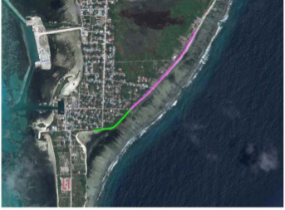

Figure 2.2 – Site Layout (Pink Line indicate the area proposed for new revetment and green line indicate the existing seawall)

3.0 Site Organization Chart

4.0 Details of Bonds, Insurance and Guarantees

No | Description | Bond/Policy No | Value with GST (MVR) | Provider Name | Validity Period
1 | Performance Guarantee | LG/MVR/228/2016 | 1,410,124.33 | Allied Insurance Company Male | 27-11-2016 31-12-2017
2 | Advance Payment Guarantee | LG/MVR/244/2016 | 3,391,368.56 | BOC Male | 26-12-2016  25-12-2017

5.0 Details of Payment

Progress of payments against is as follows.
No | Payment Description | Submitted |  | Certified |  | Cumulative Received Amount (MVR) with GST
 |  | Date | Amount (MVR) with GST | Date | Amount (MVR) with GST
1 | Advance Payment | 26-12-2016 | 3,391,368.56 | 15-02-2017 | 3,391,368.56 | 3,391,368.56
2 | IPA - 01 | 15-05-2017 | 2,715,807.91 | 31-05-2017 | 2,715,807.91 | 6,107,176.47
3 | IPA - 02 | 15-05-2017 | 2,106,973.87 | 31-05-2017 | 2,106,973.87 | 8,214,150.35
4 | IPA - 03 | 02-06-2017 | 525,057.30

6.0 Program and Progress
6.1 Master Programme
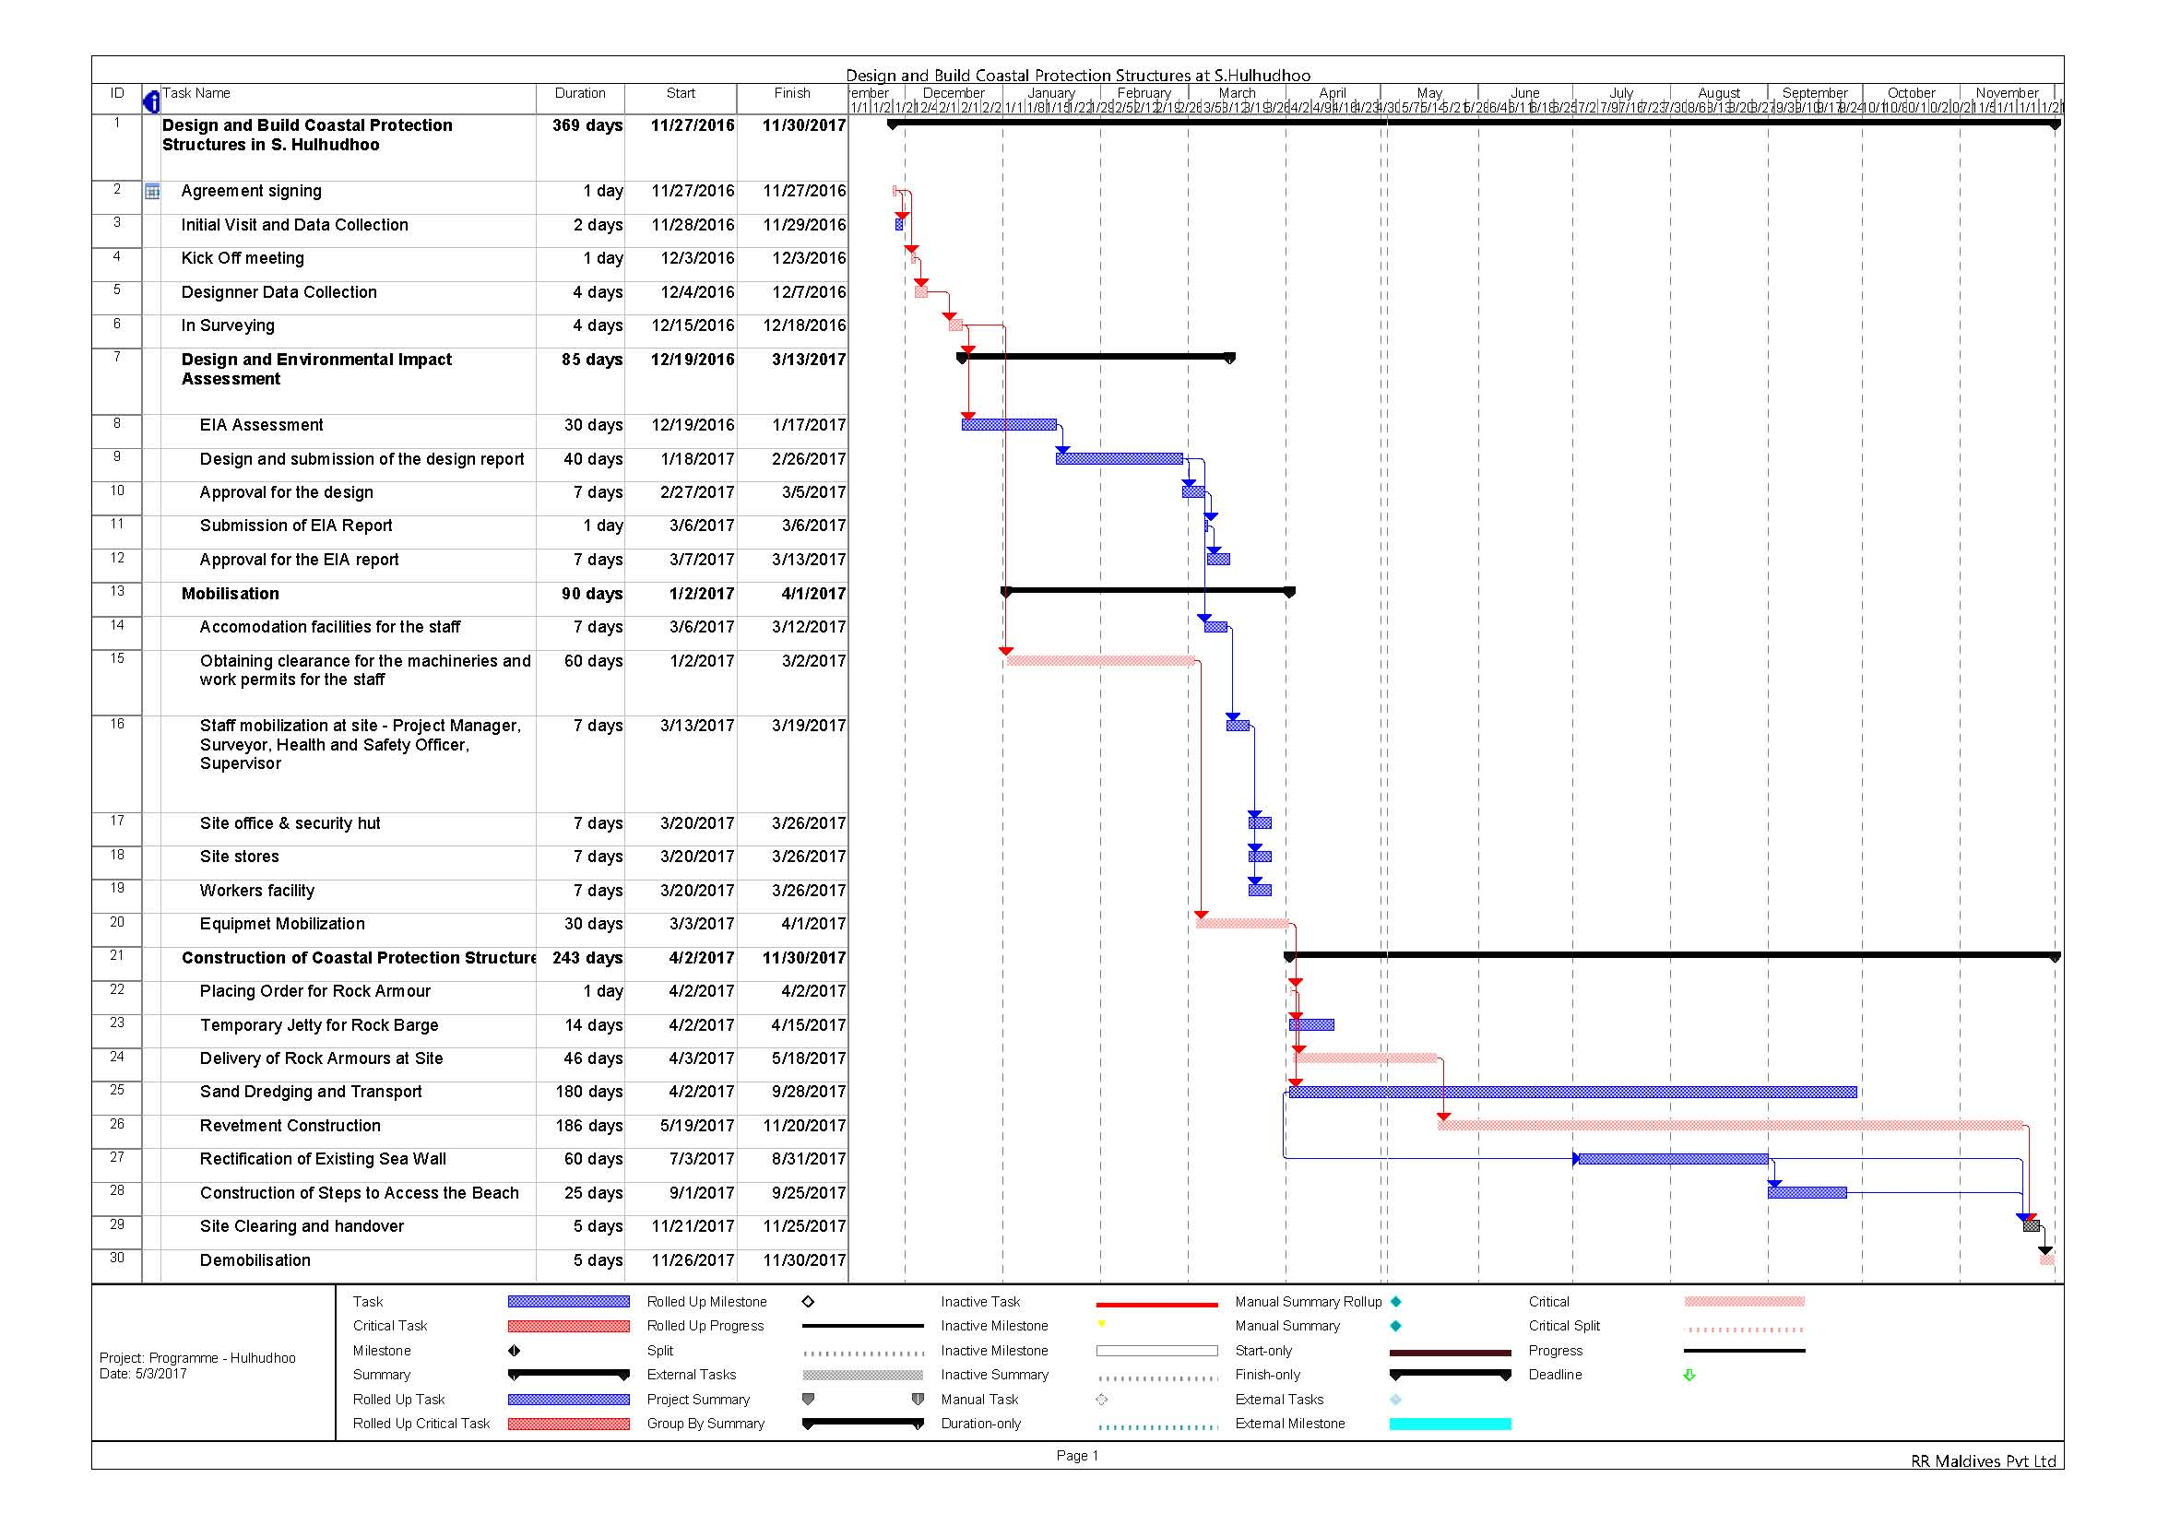
6.2 Review of Project Progress against the Programme

Evaluation as at | 31st May 2017
Master Programme | Revision 01
Contract Period | 368 Days
Elapsed Time | 185 Days
Remaining Time | 183 days

Item | Description | As per Programme |  | Physical Progress
 |  | Start | Finish | Estimated | Actual
01 | Temporary Jetty for Rock Barge | 04.02.2017 | 15.02.2017 | 100% | 100%
02 | Delivery of Rock Armours at Site | 03.04.2017 | 18.05.2017 | 61% | 100%
03 | Sand Dredging and Transport | 02.04.2017 | 28.09.2017 | 33% | 60%
04 | Revetment Construction | 19.05.2017 | 20.11.2017 | 7% | 8%
05
06
 | Total Work |  |  | 48% | 55%

6.3 Layout View of Progress
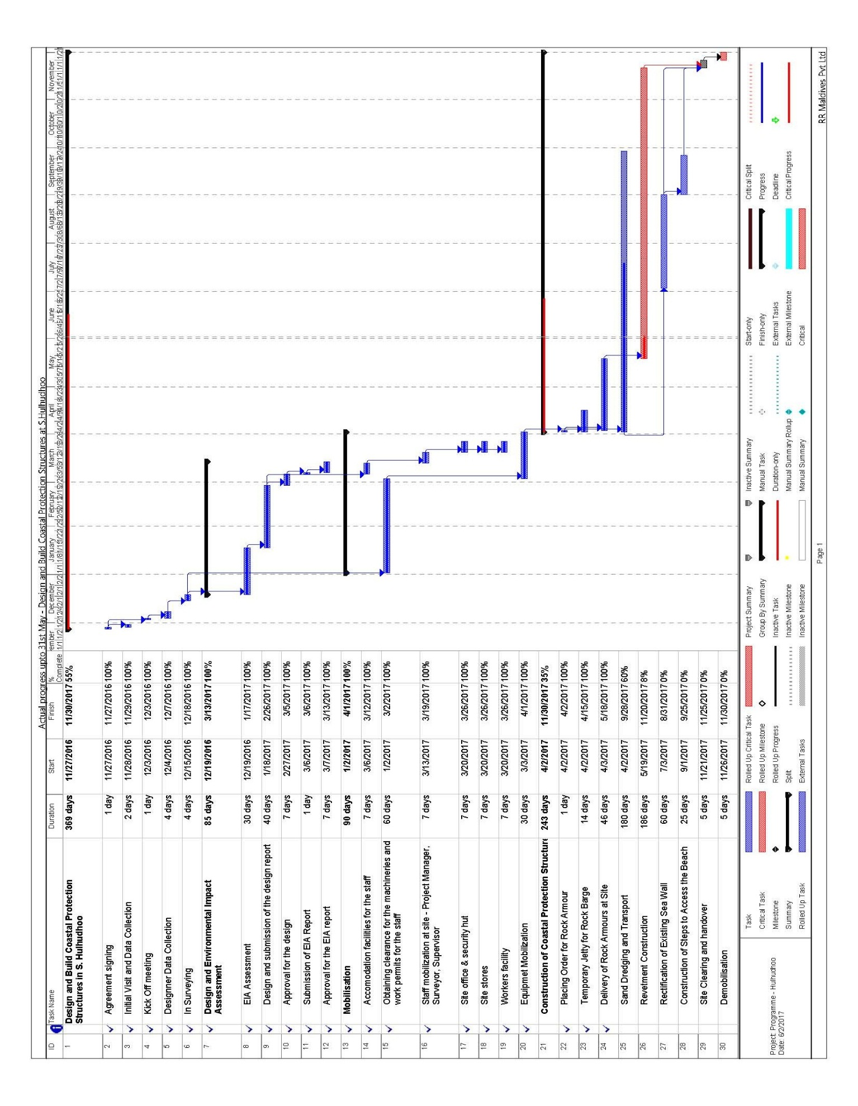

7.0 Resources Manpower and Machinery

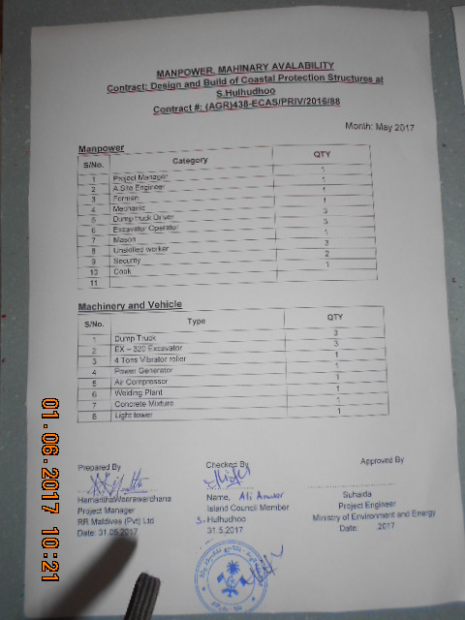

8.0 Weather Record
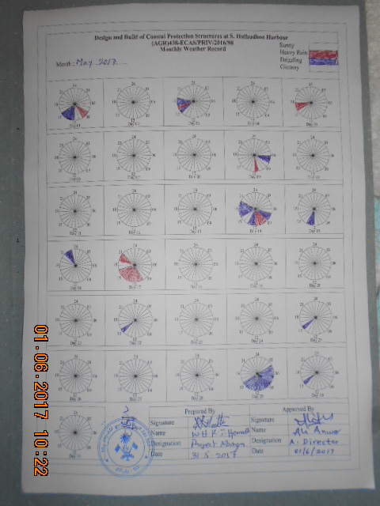

9.0 Issues and Public Complaints

9.1 Contract Issues
No any issues up to now

9.2 Public Complaints
No any public complaints up to now

- Progress Photographs

Progress Photos – May 2017
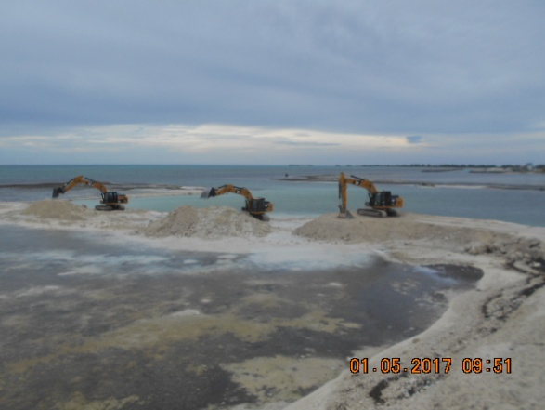  Sand Dredging (Photo I) | 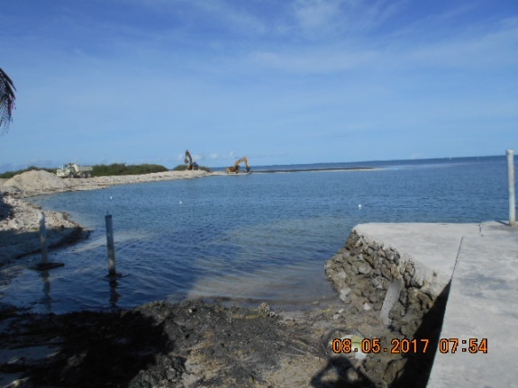  Dredge Area (Photo II)
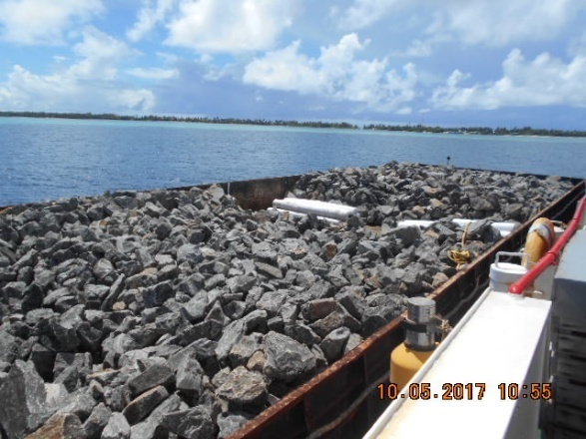  Rock Boulders and Geo Tex in Barge (Photo III) | 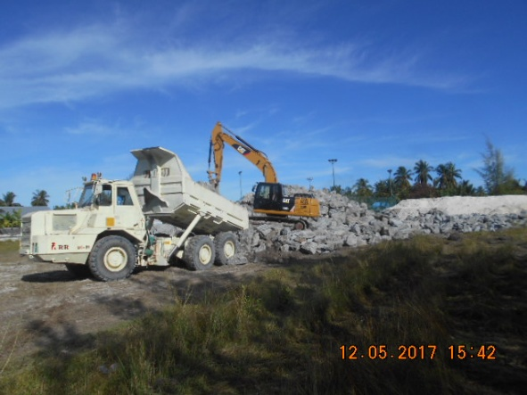  Rock Temporary Stock Piling (Photo IV)
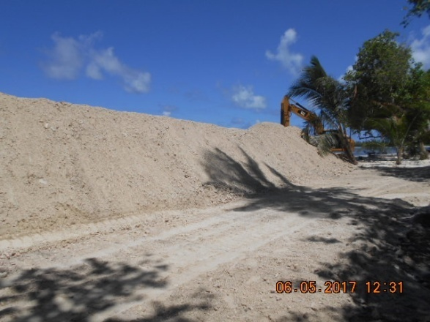  Stock Pile-Dredge Sand along the Site (Photo V) | 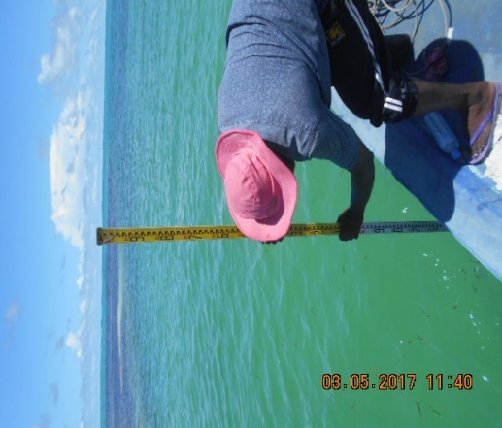  Excavated Depth Checking (Photo VI)
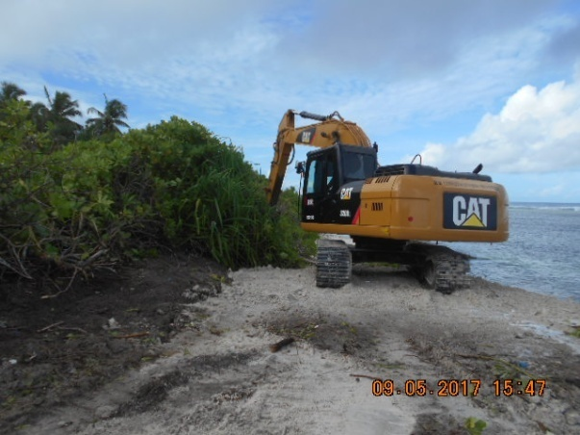  Site Clearing and Grubbing (Photo VII) | 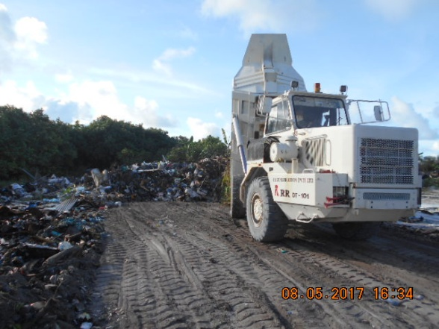  Site Debris unloading in allow location(Photo VIII)
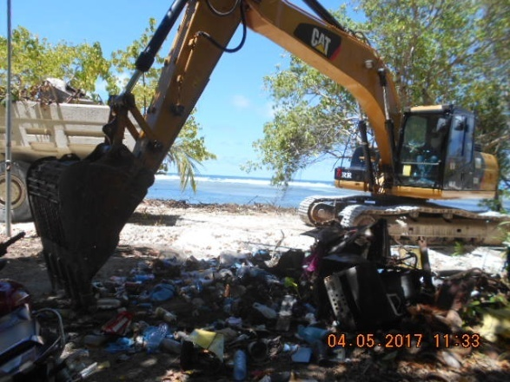  Housekeeping nearest Site Area (Photo IX) | 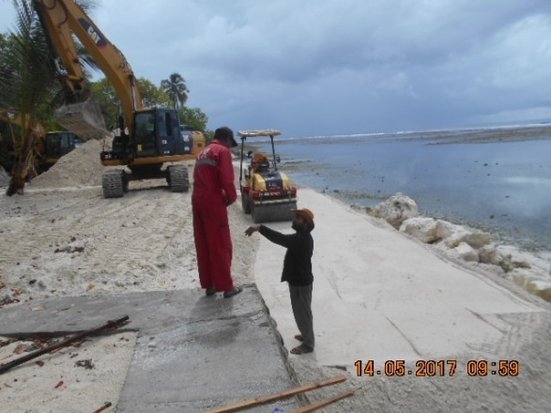  Start the Sand Compaction (Photo X)
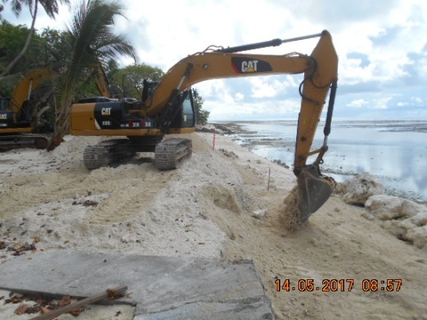  Start the Sand Bed Preparation (Photo XI) | 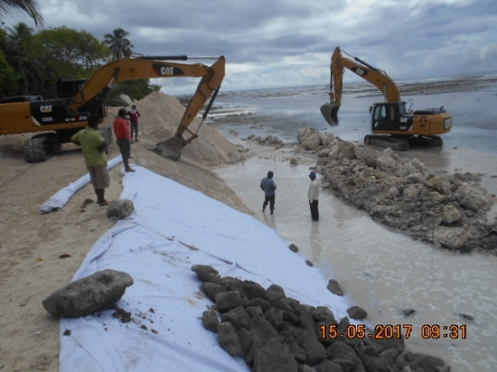  Temporary Breakwater Preparation (Photo XII)
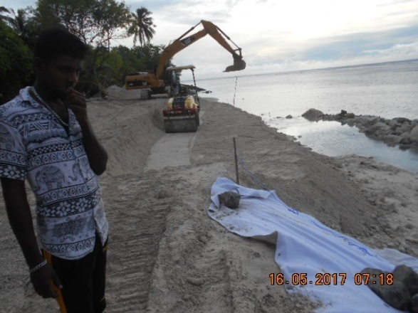  Compaction First Layer (Photo XII) | 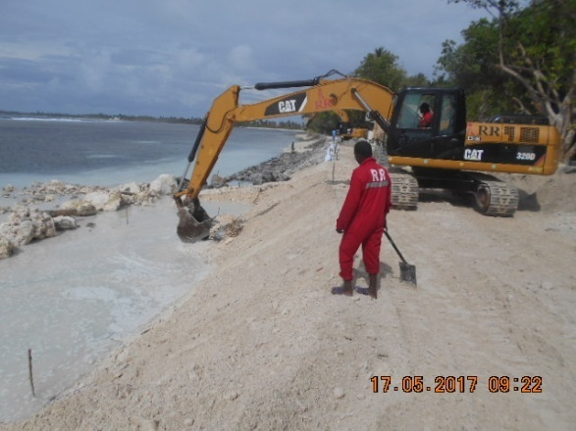  Excavation for Toe (Photo XIV)
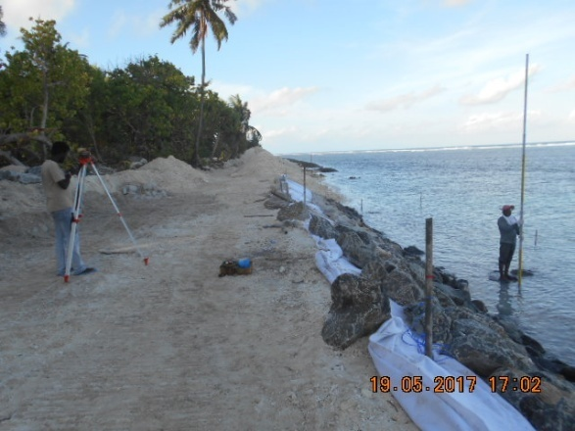  Level Checking (Photo XV) | 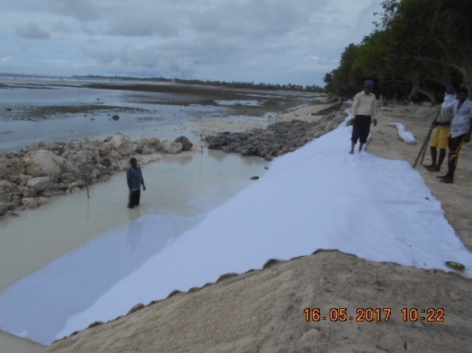  Laying Geo Textile (Photo XVI)
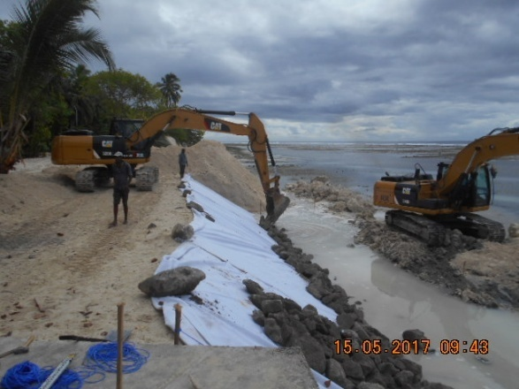  Placing of Rock Layer 2 (Photo XVII) | 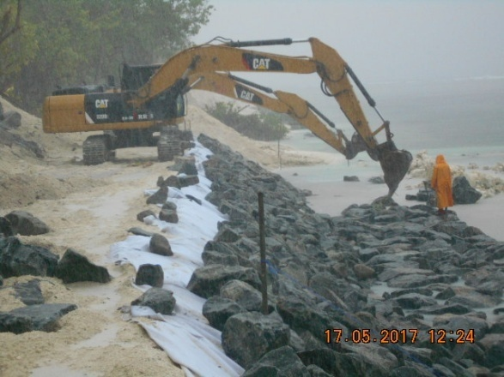  Rocks Placing in Toe (Photo XVII)
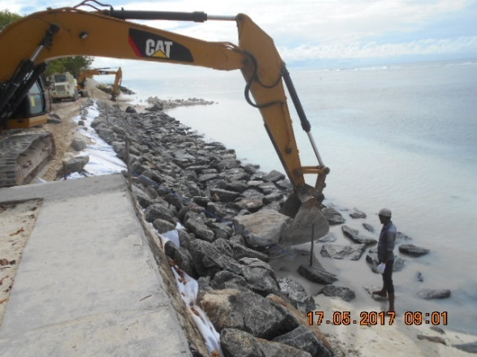  Start the Placing of Rock Layer 1 (Photo XIX) | 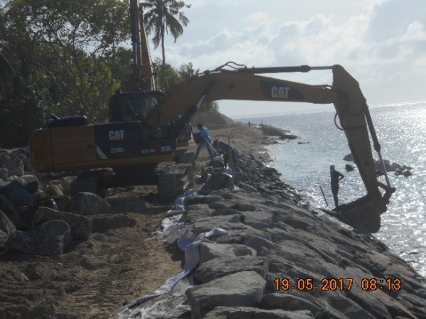  Slope Primary Amour Layer (Photo XX)
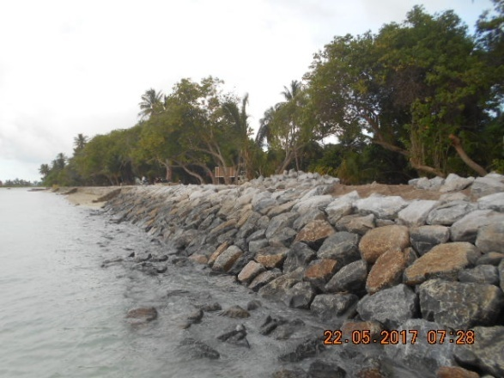  Rock Placing on Crest (Photo XXI) | 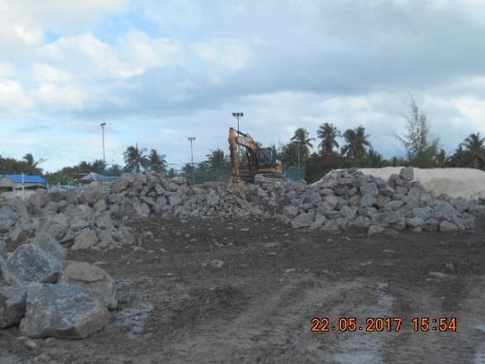  Rock Unloading (Photo XXII)
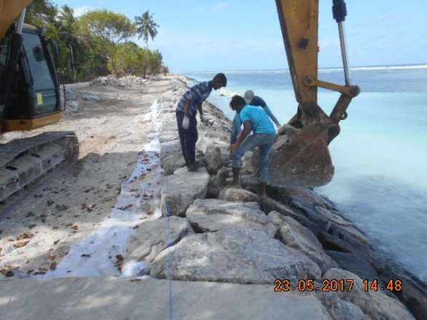  Rock Placing on Crest (Photo XXIII) | 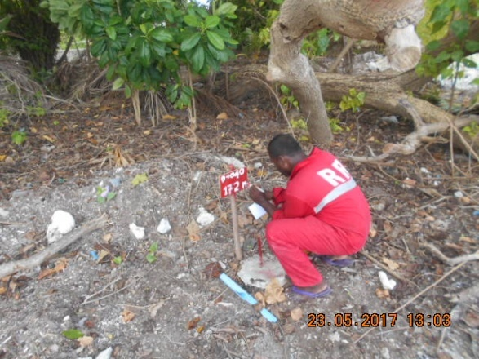  Chainage & off set Mark (Photo XXIV)

